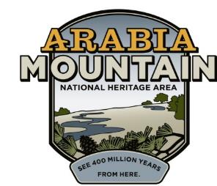
Media Contact: Angela Walton, Director of Marketing
Arabia Mountain Heritage Area Alliance
p: 404-998-8384 x5 | e: angela@arabiaalliance.org

FOR IMMEDIATE RELEASE
May 8, 2018

‘A Walk in the Woods’ with Fr. Francis Michael
Arabia Alliance presents nature walk at the Monastery of the Holy Spirit

STONECREST, Ga. – Join the Monastery of the Holy Spirit's naturalist, land manager, and former Abbott Fr. Francis Michael on a walk through the woods where you will discover the natural treasures of the Monastery's landscapes. Walks are scheduled for May 12, June 16 and June 30 from 9 a.m. to noon.
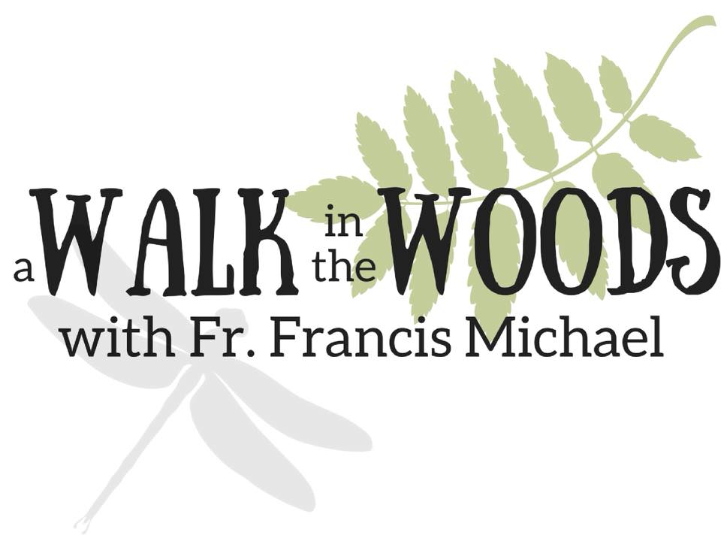
With over 2,000 acres, the Monastery of the Holy Spirit includes the Abbey Church, the Monastic Heritage Center, and the Honey Creek Woodlands Natural Cemetery. But what many do not know is that the Monastery is also the largest protected privately-owned green space in the Atlanta area, and home to the highest concentration of butterflies ever observed in a single day east of Texas.

Let Fr. Francis Michael guide you through the forest and share the natural wonders he has discovered in more than 40 years of exploring and studying the plants, animals, and insects around the Monastery.

The tour is limited to 20 participants and pre-registration is required. Tickets are $15 and available online at http://walkinthewoods.bpt.me.

Participants will meet in front of the Abbey Store shortly before 9 a.m. and are encouraged to bring plenty of water and insect repellent; wear sturdy walking shoes and long pants; and be prepared for a lot of walking, standing, and whatever elements Mother Nature decides to share with us.

This guided tour is sponsored by the Arabia Mountain Heritage Area Alliance, a non-profit dedicated to preserving, promoting, and protecting the Arabia Mountain National Heritage Area.

For more information about the nature walk at the Monastery, contact Sarah Lisle, Director of Interpretation, at sarah@arabiaalliance.org or 404-998-8384 x6.

To learn more about Arabia Alliance and the Arabia Mountain National Heritage Area, visit www.arabiaalliance.org.

###

