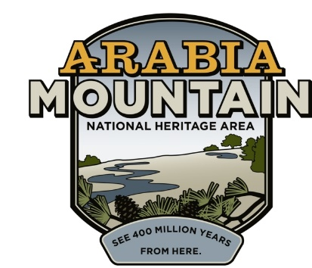
Media Contact: Angela Walton, Director of Marketing
Arabia Mountain Heritage Area Alliance
p: 404-998-8384 x5 | e: angela@arabiaalliance.org

FOR IMMEDIATE RELEASE
April 2, 2018

Junior Rangers Ramble in the Arabia Mountain National Heritage Area during National Park Week in April

STONECREST, Ga. – To kickoff National Park Week and National Junior Ranger Day on April 21, the Arabia Mountain Heritage Area Alliance presents its first-ever Junior Ranger Ramble. Great for the entire family, the event encourages kids ages 5 and up to discover the Arabia Mountain National Heritage Area through guided and self-guided activities at many of our partner sites.

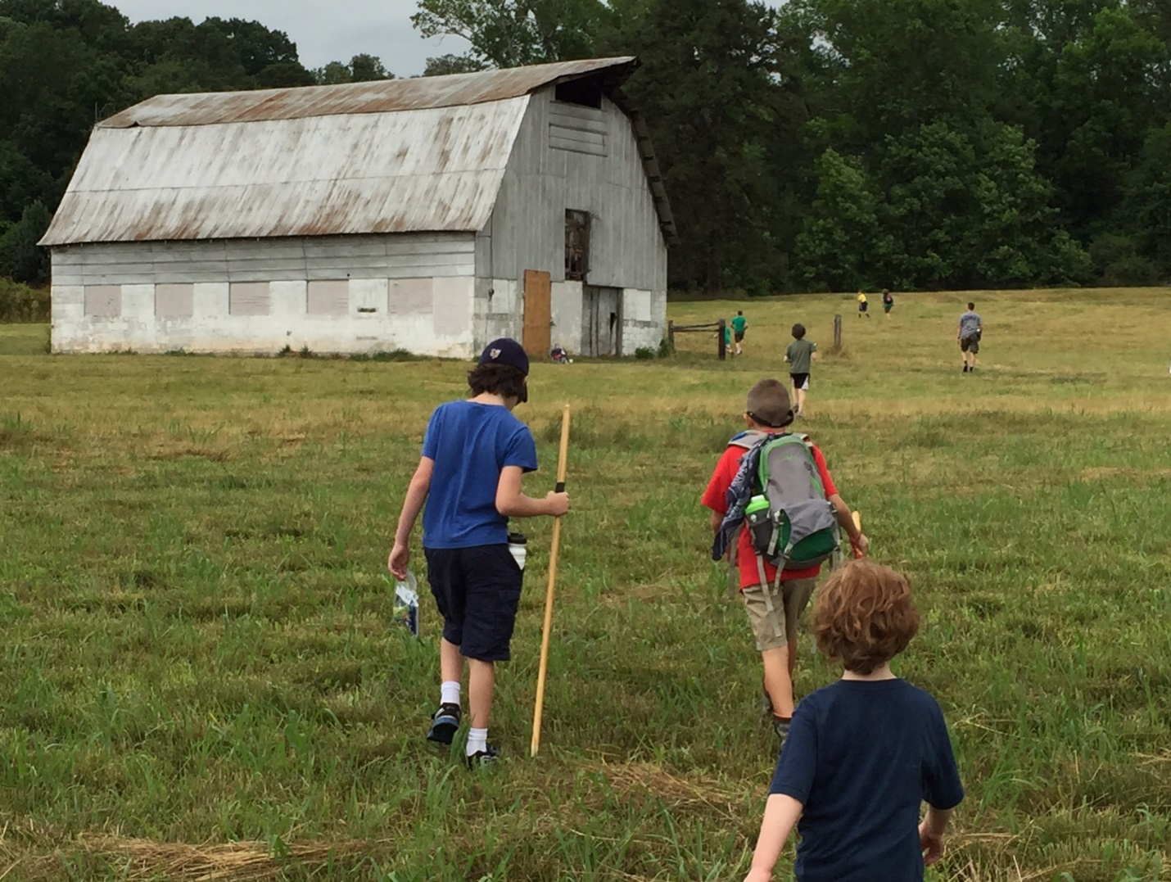
Kids hiking and exploring along the Meadow Loop Trail at historic Vaughters’ Farm.

The adventure begins at the Davidson-Arabia Mountain Nature Preserve where families will pick-up a passport with a schedule and self-guided activities including guided hikes, birdwatching, nature study and more. After checking in, families can ramble at their leisure at sites across the National Heritage Area including AWARE Wildlife Center, Panola Mountain State Park, the Monastery of the Holy Spirit, Vaughters’ Farm, Historic Lithonia, and Flat Rock Archives.

-more-
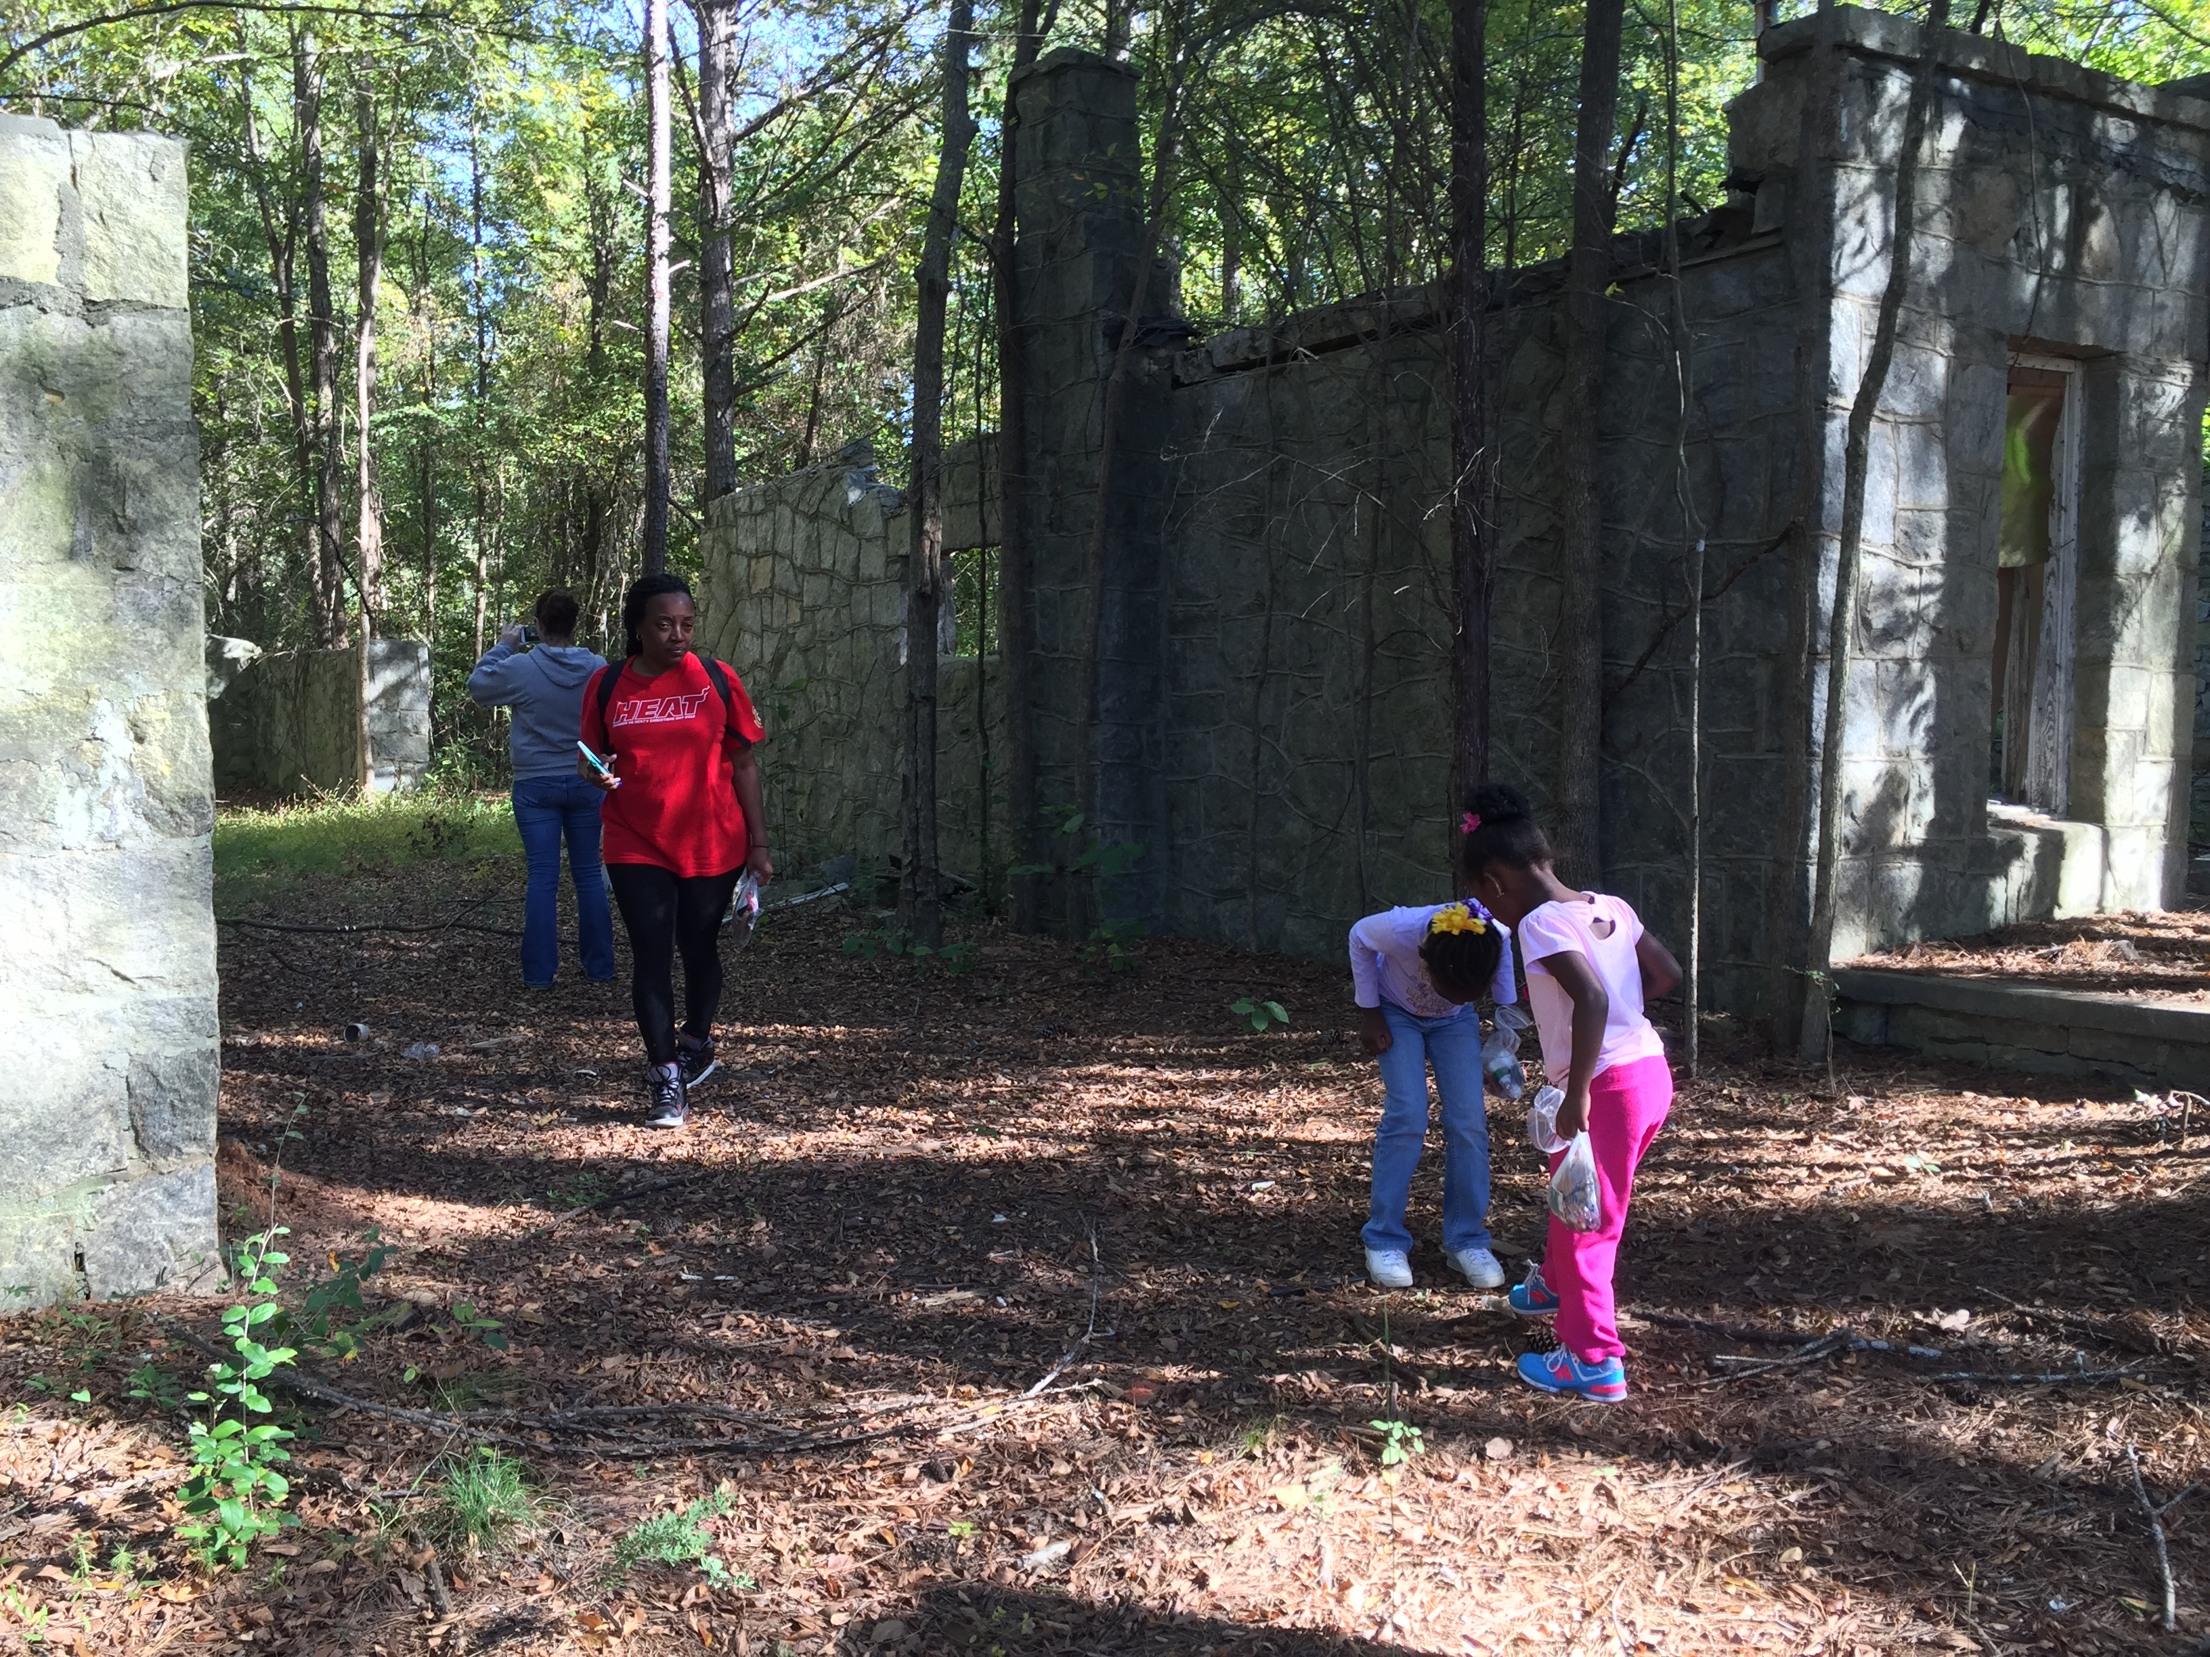
Family discovering rock remains of old quarry buildings, homestead foundations and other ruins at the Davidson-Arabia Mountain Nature Preserve.

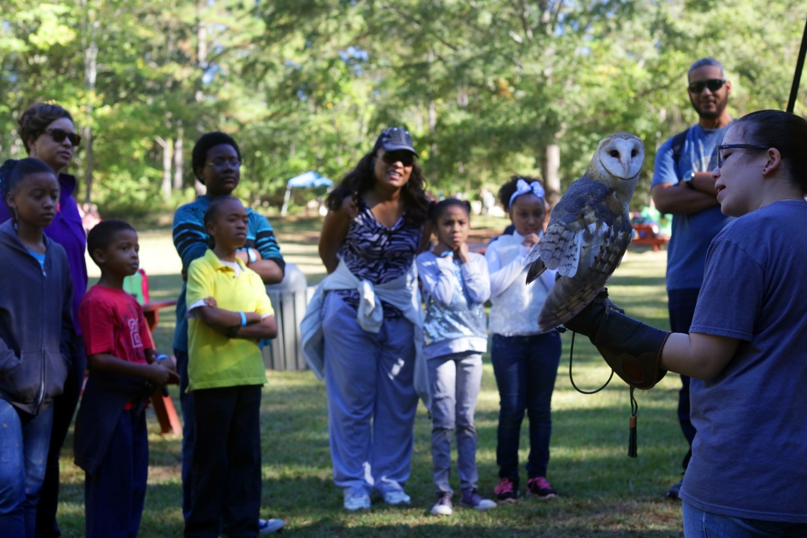
AWARE ambassador handling an owl in front of families during a wildlife demonstration.

-more-

Participants who complete five activities will become official Arabia Mountain National Heritage Area Junior Rangers and sworn-in during a ceremony at the Davidson-Arabia Mountain Nature Center at 4 p.m. Junior Rangers will receive a badge, certificate and a special prize; accommodations will be made for anyone who completes the activities and cannot attend the ceremony.
The Ramble runs from 10 a.m. until 4 p.m. on April 21 with check-in beginning at the Davidson-Arabia Mountain Nature Preserve. Registration is $5 and the first 50 kids to sign-up will receive a Rambler’s Discovery Kit that includes tools to aid in exploration.
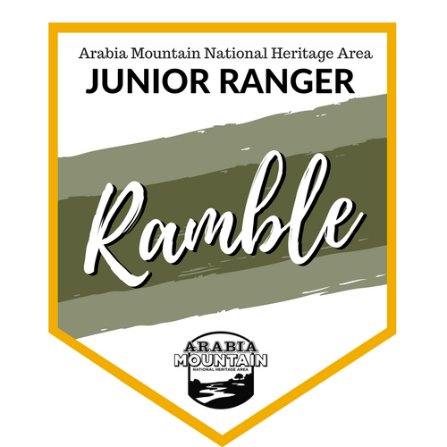

Pre-registration for Junior Ranger Rambler is encouraged online at https://juniorrangerramble.brownpapertickets.com.

To download the passport and complete activities on your own, visit http://arabiaalliance.org/juniorrangerramble.

For more information about Junior Ranger Rambler or the AMNHA Junior Ranger Program, contact Sarah Lisle, Director of Interpretation, at sarah@arabiaalliance.org or 404-998-8384 x6.

National Park Week is April 21-29 and is a time to explore amazing places, discover stories of history and culture, volunteer, and find your park. For more information, please visit https://www.nps.gov/subjects/npscelebrates/index.htm.

###

About Arabia Alliance
The Arabia Mountain Heritage Area Alliance is a local nonprofit dedicated to protecting, connecting and sharing the unique history, rich culture and engaging landscapes of the Arabia Mountain National Heritage Area for the benefit and enjoyment of all generations. The Arabia Mountain National Heritage Area is an affiliate of the National Park Service. For more information, visit www.arabiaalliance.org, or find us on Facebook at www.facebook.com/ArabiaMountainNationalHeritageArea

